Lab programs
- Aim
To develop a Python program to perform grade distribution analysis, demonstrate object detection, and compare two approaches for heart disease prediction.
- Algorithm
- Start the program.
- Store the grades and the number of students in lists.
- Display the grade distribution.
- Identify the maximum and minimum grades based on student counts.
- Calculate the combined percentage of students who secured grades A and S.
- Display sample object labels.
- Get the age and blood pressure as input.
- Apply two simple rule-based prediction methods.
- Display the prediction results.
- Stop the program.

- Procedure
- Open a Python compiler or IDLE.
- Type the Python program in the editor.
- Store the grades F, E, D, C, B, A, S and their student counts.
- Execute the program to display the grade statistics.
- Display sample object names as an object detection demonstration.
- Enter the age and blood pressure when prompted.
- Compare the results of the two prediction rules.
- Observe the output and record the results.
Python Code

import matplotlib.pyplot as plt

# 1. Grade Distribution
grades = ['F', 'E', 'D', 'C', 'B', 'A', 'S']
students = [3, 4, 5, 8, 9, 7, 4]
total = sum(students)

# Pie Chart
plt.figure(figsize=(10, 5))
plt.subplot(1, 2, 1)
plt.pie(students, labels=grades, autopct='%1.1f%%', startangle=90)
plt.title("Grade Percentage Distribution")

# Bar Chart
plt.subplot(1, 2, 2)
bars = plt.bar(grades, students)
plt.xlabel("Grades")
plt.ylabel("Number of Students")
plt.title("Students by Grade")

for bar in bars:
plt.text(bar.get_x() + bar.get_width()/2,
bar.get_height(), str(int(bar.get_height())),
ha='center', va='bottom')

plt.tight_layout()
plt.show()

print("Maximum grade:", grades[students.index(max(students))])
print("Minimum grade:", grades[students.index(min(students))])
print("A and S combined percentage:", (7 + 4) / total * 100, "%")

# 2. Object Detection using YOLO
from ultralytics import YOLO

model = YOLO("yolov8n.pt")
results = model.predict(source="image.jpg", show=True)

for result in results:
for box in result.boxes:
print("Detected object:", model.names[int(box.cls[0])])

# 3. Compare Heart Disease Algorithms
import pandas as pd
from sklearn.model_selection import train_test_split
from sklearn.preprocessing import StandardScaler
from sklearn.linear_model import LogisticRegression
from sklearn.ensemble import RandomForestClassifier
from sklearn.metrics import accuracy_score

data = pd.read_csv("heart.csv")
X = data.drop("target", axis=1)
y = data["target"]

X_train, X_test, y_train, y_test = train_test_split(
X, y, test_size=0.2, random_state=42, stratify=y
)

scaler = StandardScaler()
X_train = scaler.fit_transform(X_train)
X_test = scaler.transform(X_test)

models = {
"Logistic Regression": LogisticRegression(max_iter=1000),
"Random Forest": RandomForestClassifier(n_estimators=100, random_state=42)
}

for name, model in models.items():
model.fit(X_train, y_train)
prediction = model.predict(X_test)
accuracy = accuracy_score(y_test, prediction) * 100
print(name, "Accuracy:", round(accuracy, 2), "%")
output:
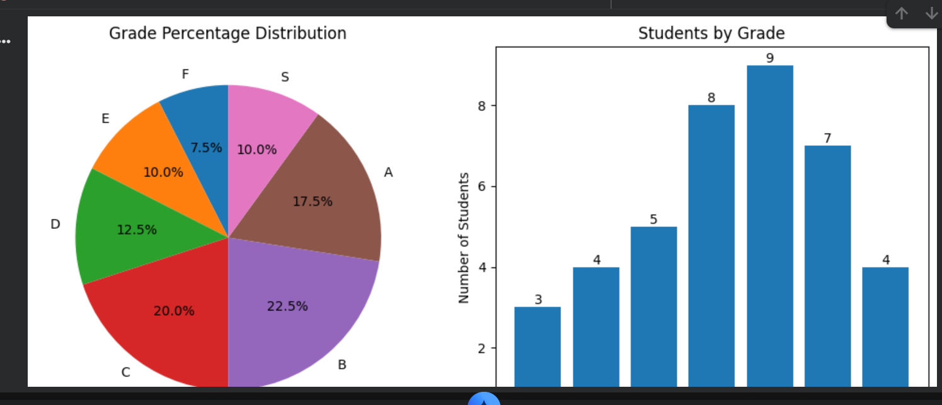
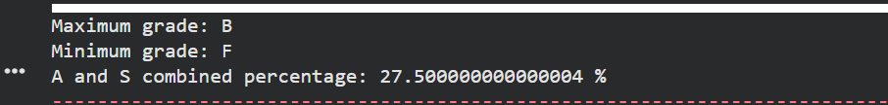
Result:
Thus, the Python program was executed successfully to represent the grade distribution using a pie chart and a bar graph. Grade B had the maximum number of students (9), and grade F had the minimum number of students (3). The combined percentage of students who secured grades A and S was 27.5%.
2.

